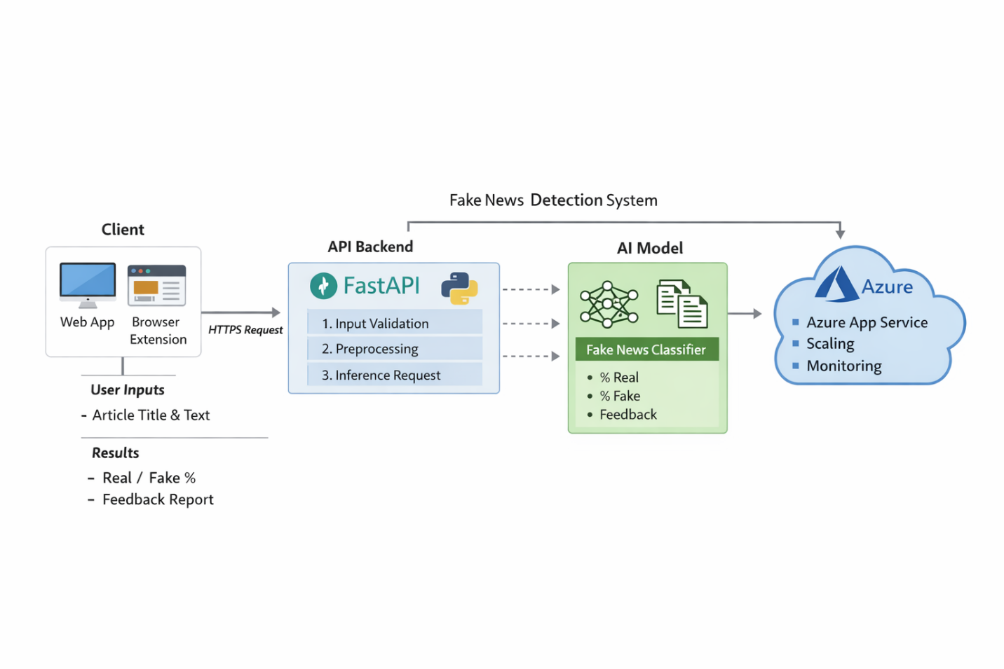

Architecture Scheme – Fake News Detection Application
1️⃣ Overview
The system is a lightweight, cloud-deployed AI application that allows users to submit an article (title + text) and receive a classification indicating the probability of the article being real or fake, along with structured feedback.
The architecture follows a stateless client–server model, deployed on Microsoft Azure, with real-time inference and no persistent data storage.

2️⃣ High-Level Architecture Structure
The system consists of three main layers:

Client Layer (Website or Browser Extension)
Application Layer (Python Backend API)
AI Model Layer (Inference Engine)
Cloud Infrastructure Layer (Azure Hosting)

3️⃣ Client Layer
Responsibility:
Collect user input (article title + text)
Send HTTPS request to backend API
Display classification results
Characteristics:
Runs in the user’s browser
No authentication required
No local data persistence
Communicates via REST API over HTTPS
This layer is purely responsible for user interaction and presentation logic.

4️⃣ Application Layer (Backend API)
Responsibility:
Receive and validate input
Preprocess text
Pass input to the AI model
Format and return prediction results
Key Characteristics:
Implemented in Python
Stateless architecture (no session storage)
Returns JSON responses
Handles real-time inference requests
Processing Flow:
Input validation
Text preprocessing
Model inference
Probability formatting
Feedback generation
JSON response
Because the backend is stateless, it can scale horizontally.

5️⃣ AI Model Layer
Responsibility:
Perform fake news classification
Output:
Probability of “Real”
Probability of “Fake”
Final classification label
Feedback explanation
Characteristics:
Model is loaded into memory at application startup
Inference-only (no training in production)
Integrated within backend service
Optimized for low-latency responses
This layer is logically separated but technically embedded in the backend service.

6️⃣ Cloud Infrastructure Layer (Azure)
Hosting Environment:
Deployed on Microsoft Azure
Hosted using App Service, Container Apps, or Kubernetes (depending on scaling needs)
Optionally containerized with Docker
Infrastructure Responsibilities:
Application hosting
Auto-scaling
Load balancing
TLS/HTTPS encryption
Monitoring and logging
The infrastructure layer ensures availability, reliability, and scalability.

7️⃣ Data Flow Architecture
The system follows a simple request-response flow:

User enters article text
Client sends HTTPS POST request to backend
Backend validates input
Text is preprocessed
Model performs inference
Backend formats probabilities and feedback
JSON response is returned
Client displays results
This is a synchronous, real-time inference pipeline.

8️⃣ Scalability Design
The architecture supports scalability through:
Stateless backend services
Horizontal scaling (multiple instances)
Azure auto-scaling rules
Load-balanced request handling
Since no database is used, scaling complexity is reduced.

9️⃣ Security Considerations
Even without authentication or database storage, the architecture includes:

HTTPS encryption (TLS)
CORS configuration
Basic input validation
Rate limiting (to prevent abuse)
Secure cloud deployment environment
Security is implemented at the infrastructure and API levels.

🔟 Architectural Characteristics
The system is:

Stateless
Cloud-native
API-driven
Real-time inference-based
Horizontally scalable
Lightweight (no persistence layer)

Final Architecture Summary
This architecture represents a minimal, clean AI deployment model consisting of:

A browser-based client
A stateless Python backend API
An embedded AI inference engine
Azure-managed cloud infrastructure
It is optimized for simplicity, scalability, and real-time performance.

